Elastic Load Balancer Task

1. Configure Classic Load balancer 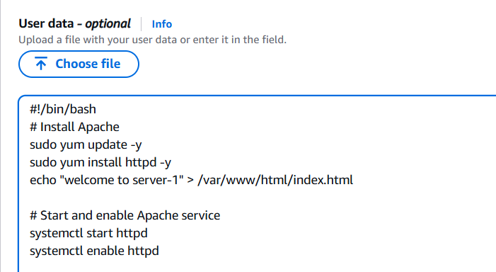
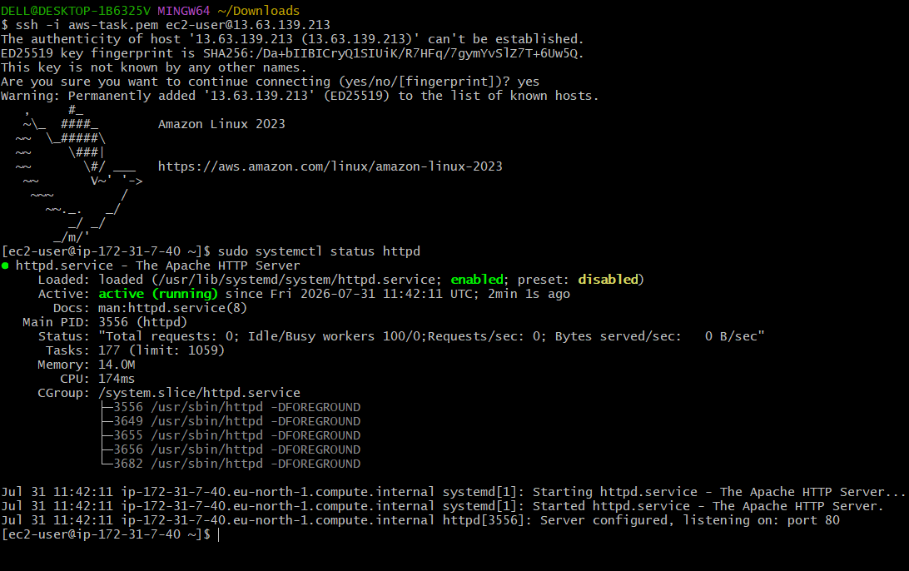
Create a security group for this load balancer, to allow the inbound rules
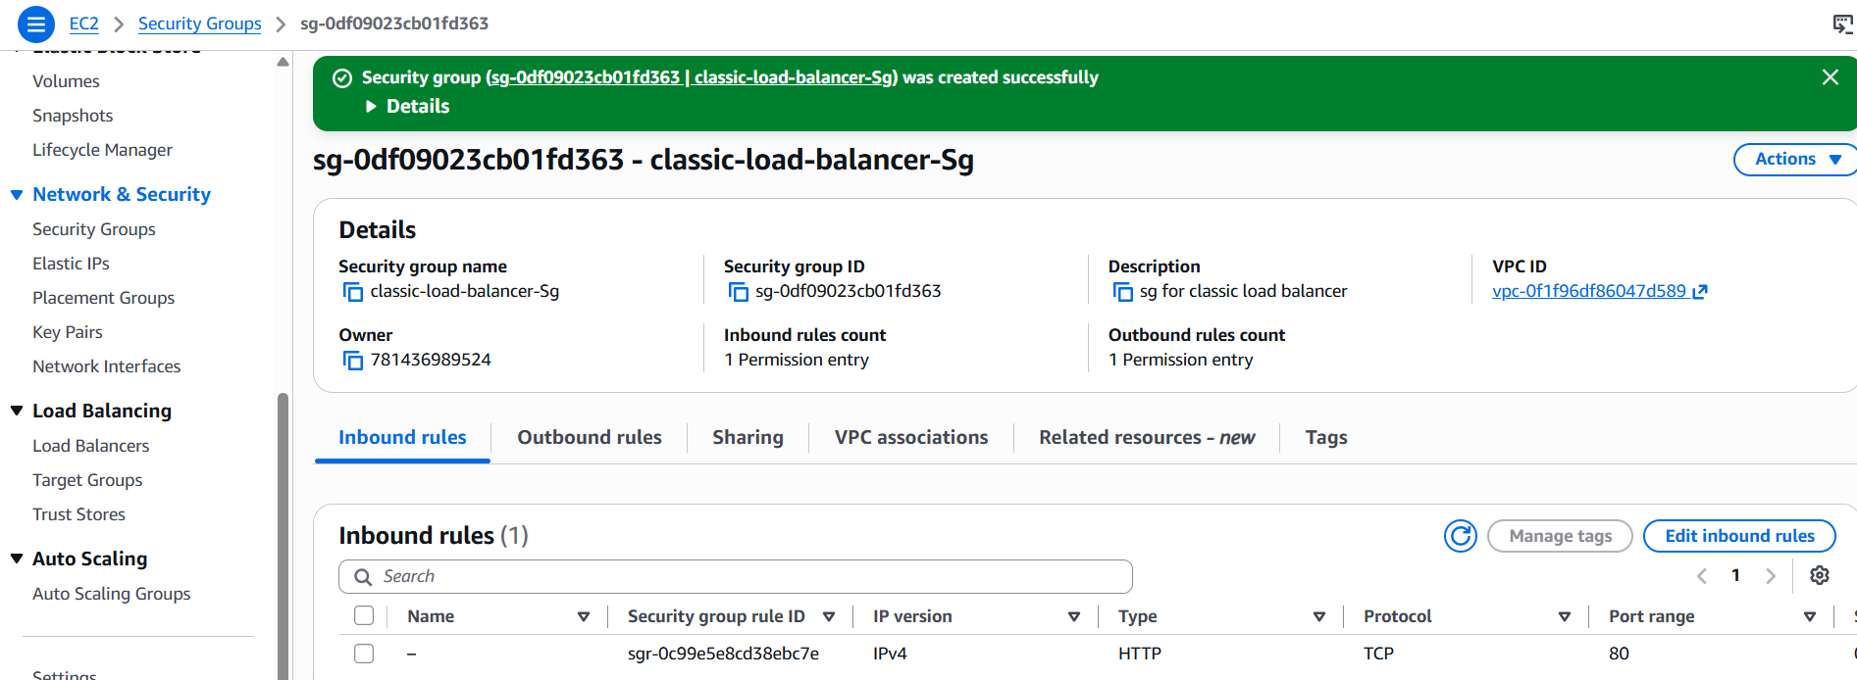
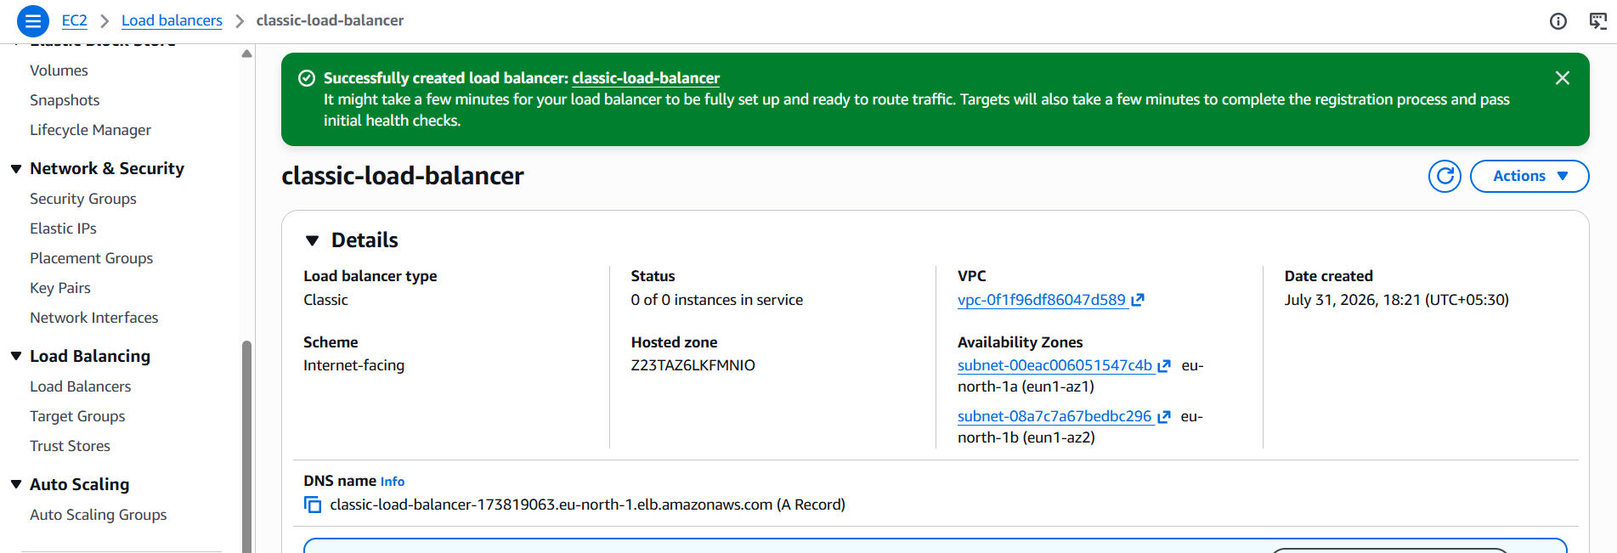
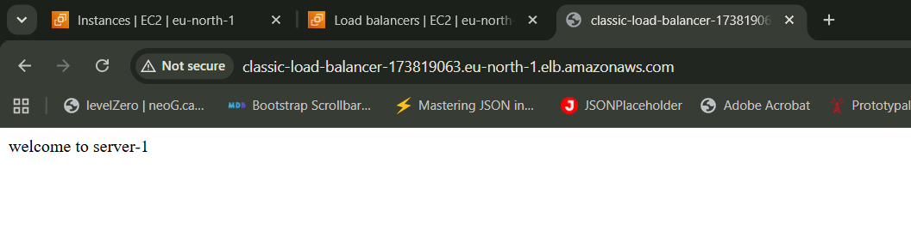
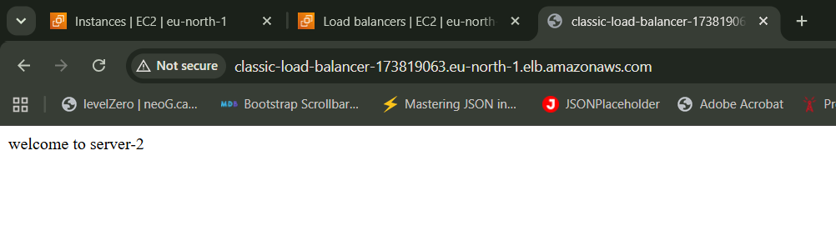
So, here it works with the DNS name in the browser
2. Configure Application Load balancer
For creating application load balancer, we need to create target group
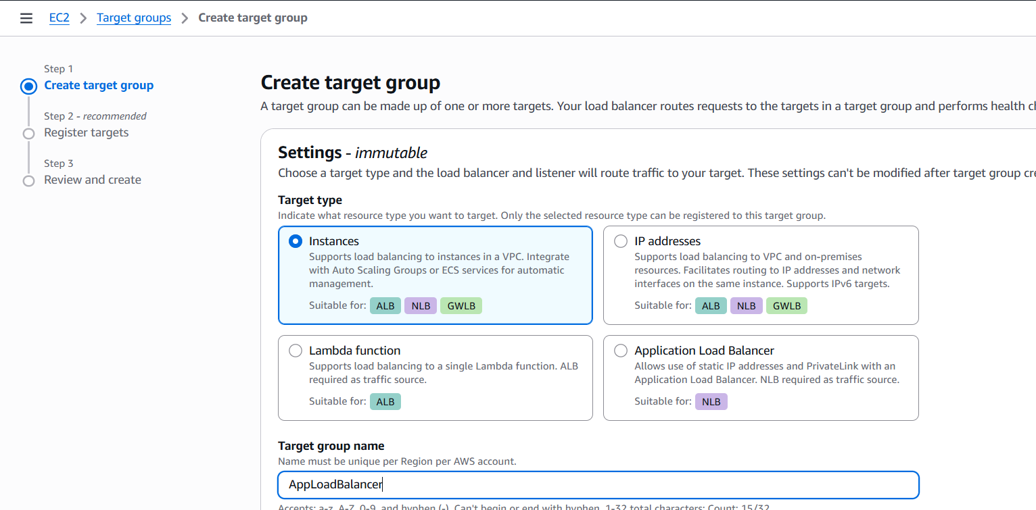
And then register the targets
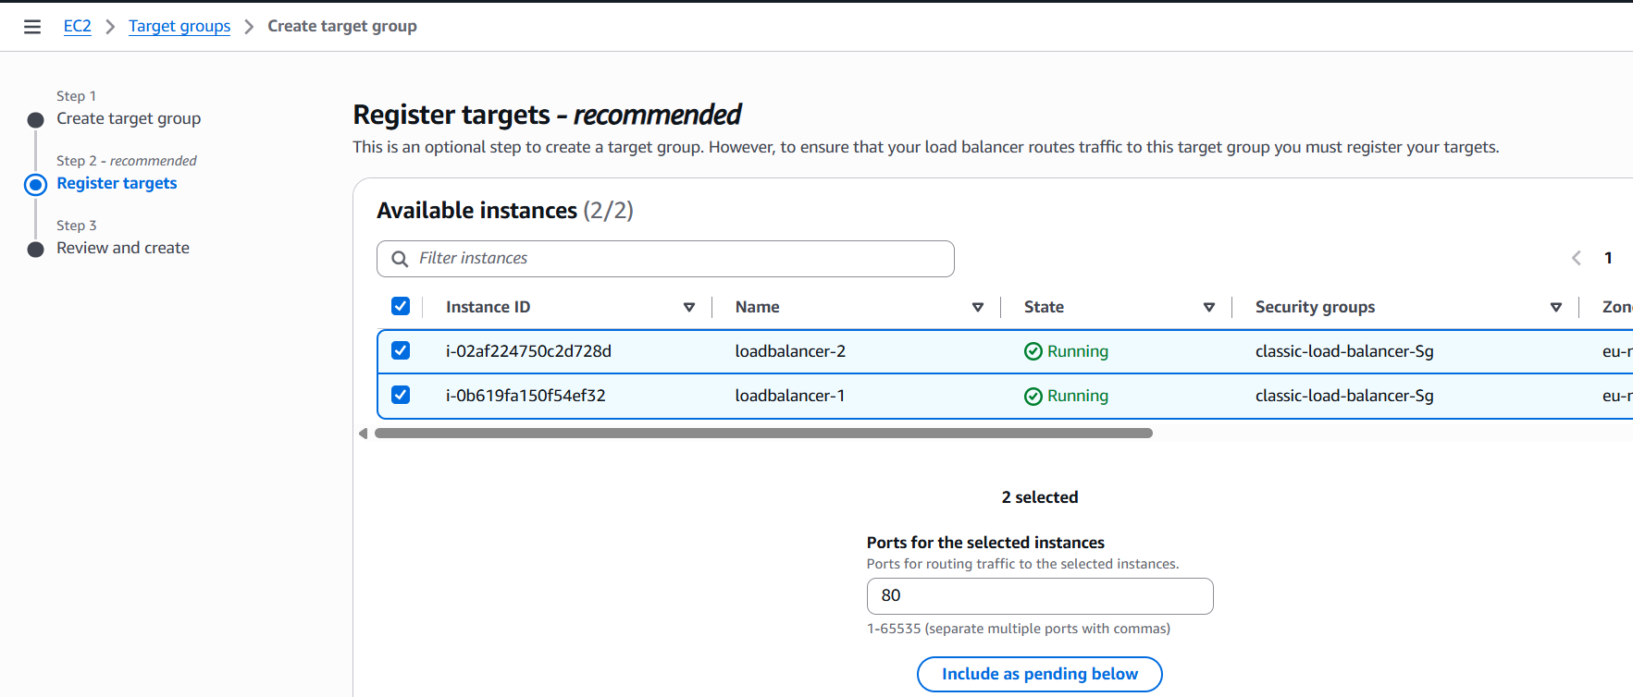
Here you need to enable the box and click on include as pending below,
Once it is done, create a load balancer and attach this target group
Attach 3 subnets in the different AZ and create
Once it is done, check for the health checks
Then copy the DNS of the load balancer and you can try it in the browser, it works as below
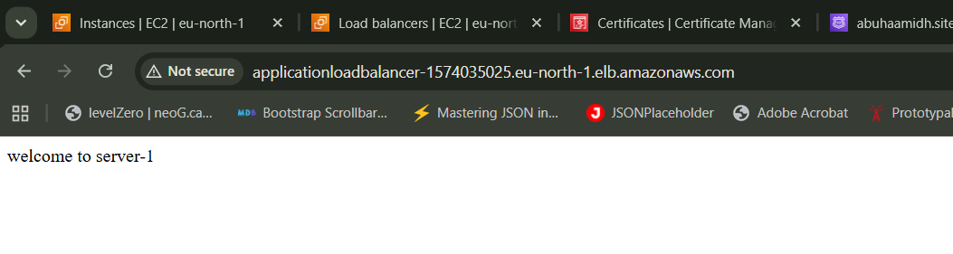
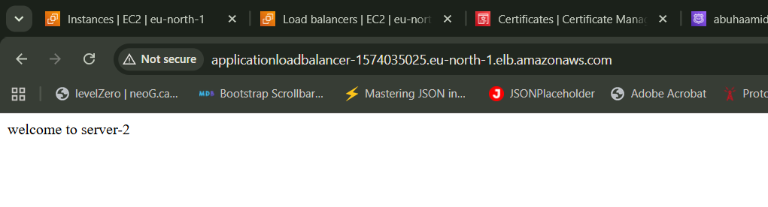

3. Configure Network Load balancer
For creating network load balancer, You need to create a target group with the below configuration
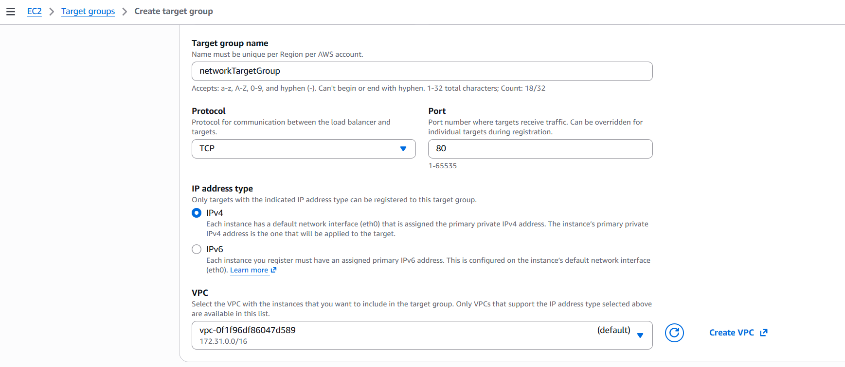
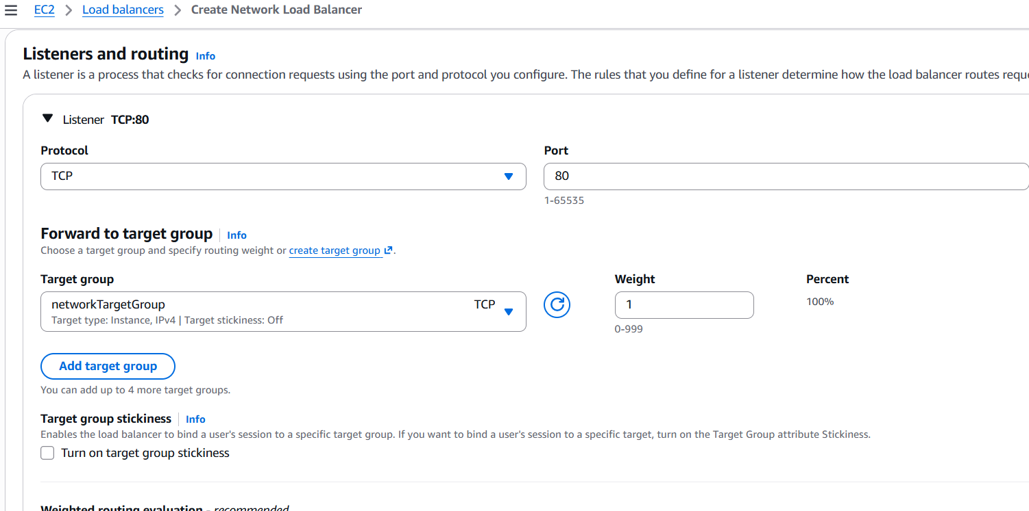
And if you copy the DNS and paste it in the browser and refresh, you can see the server gets changed
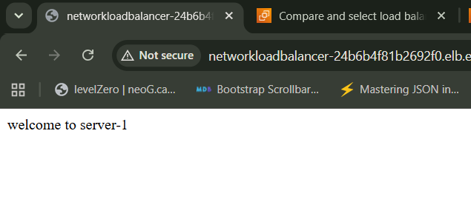
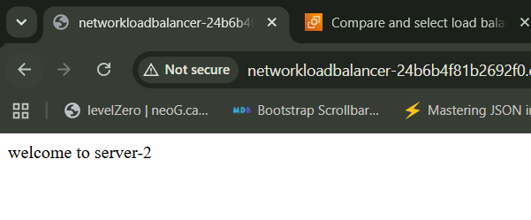

4. Attach SSL for application load balancer
Create a hosted zone
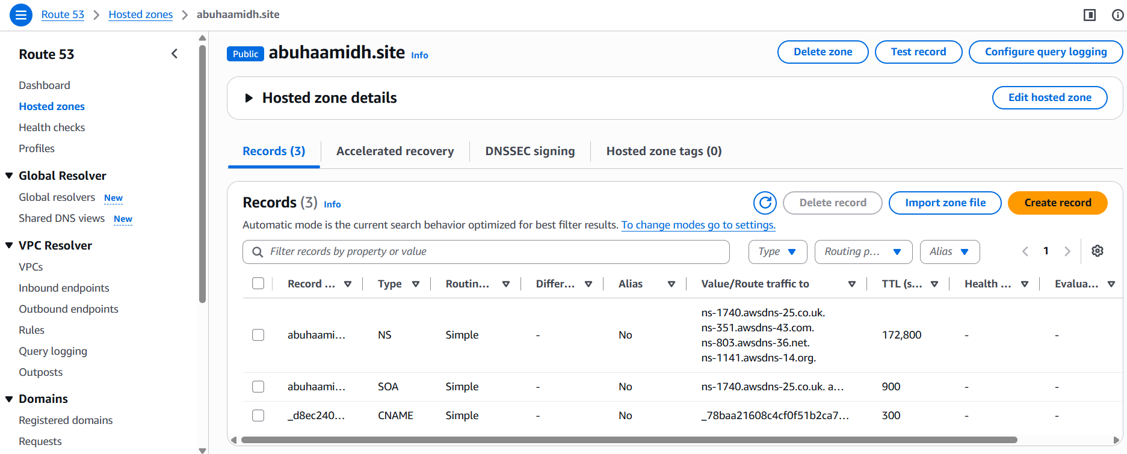
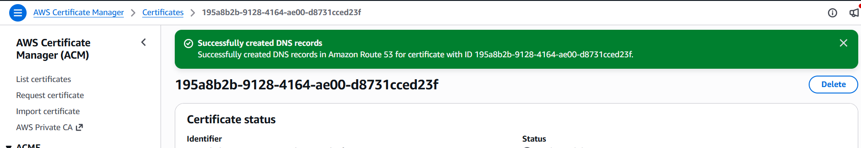
And paste the hosted zone in the DNS providor
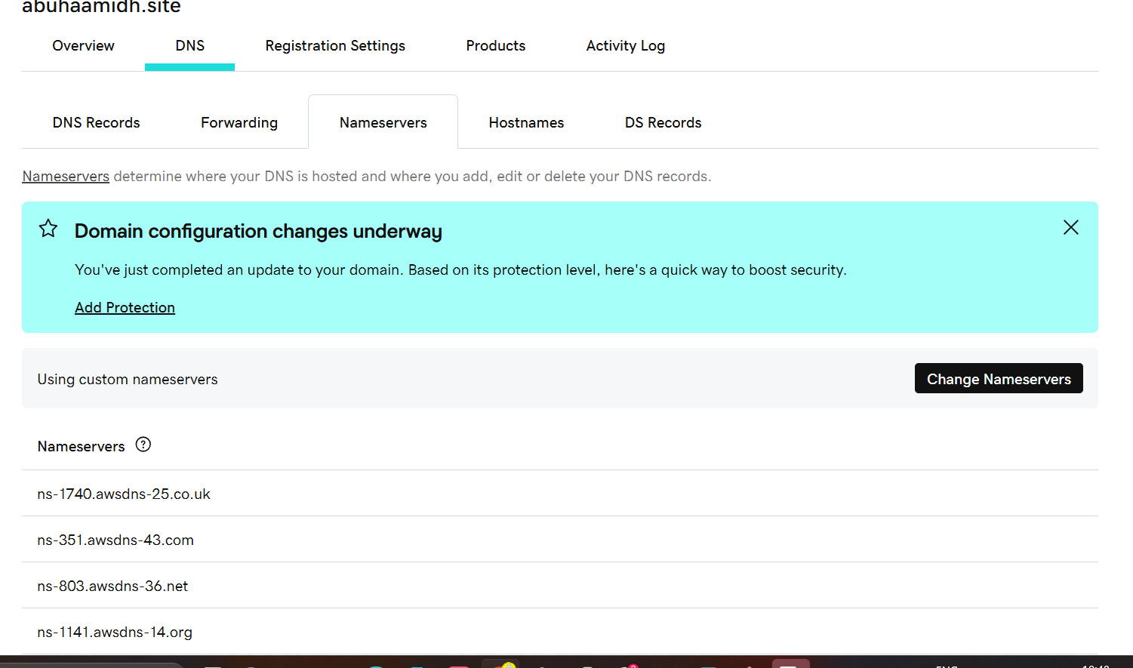
Now you can create a target group for the application load balancer
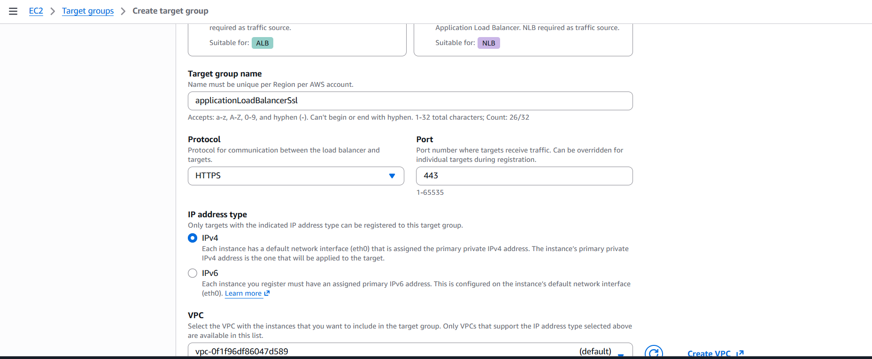
Edit inbound rules for HTTPS and port 443
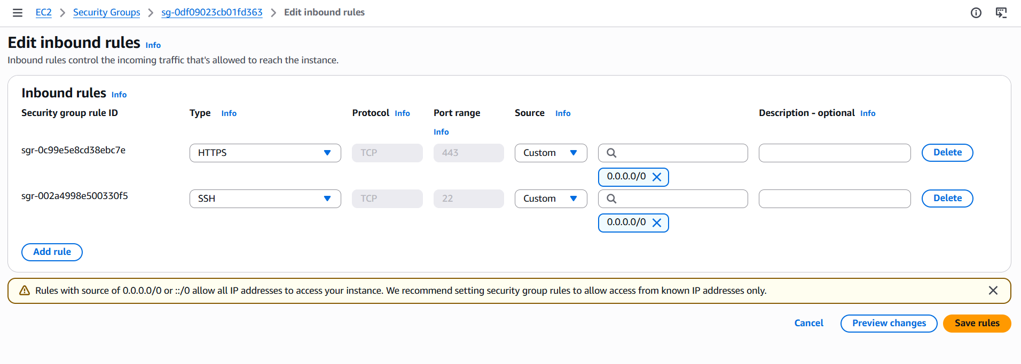
Create a application load balancer
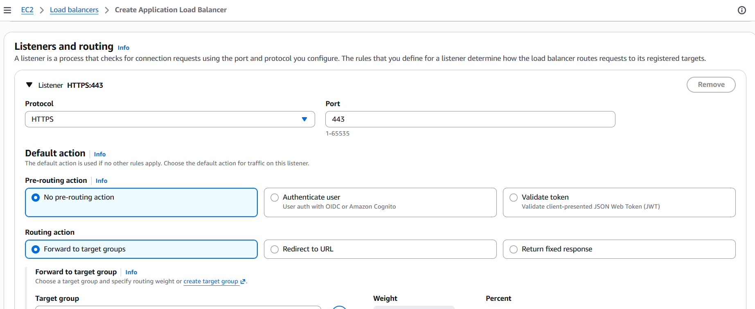
Attach the ssl certificate for that load balancer
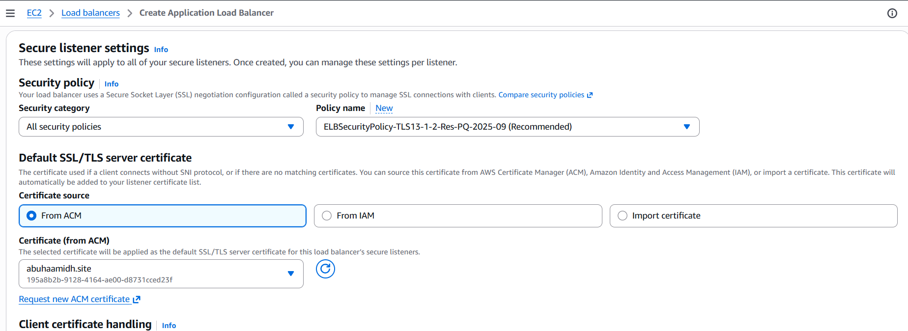
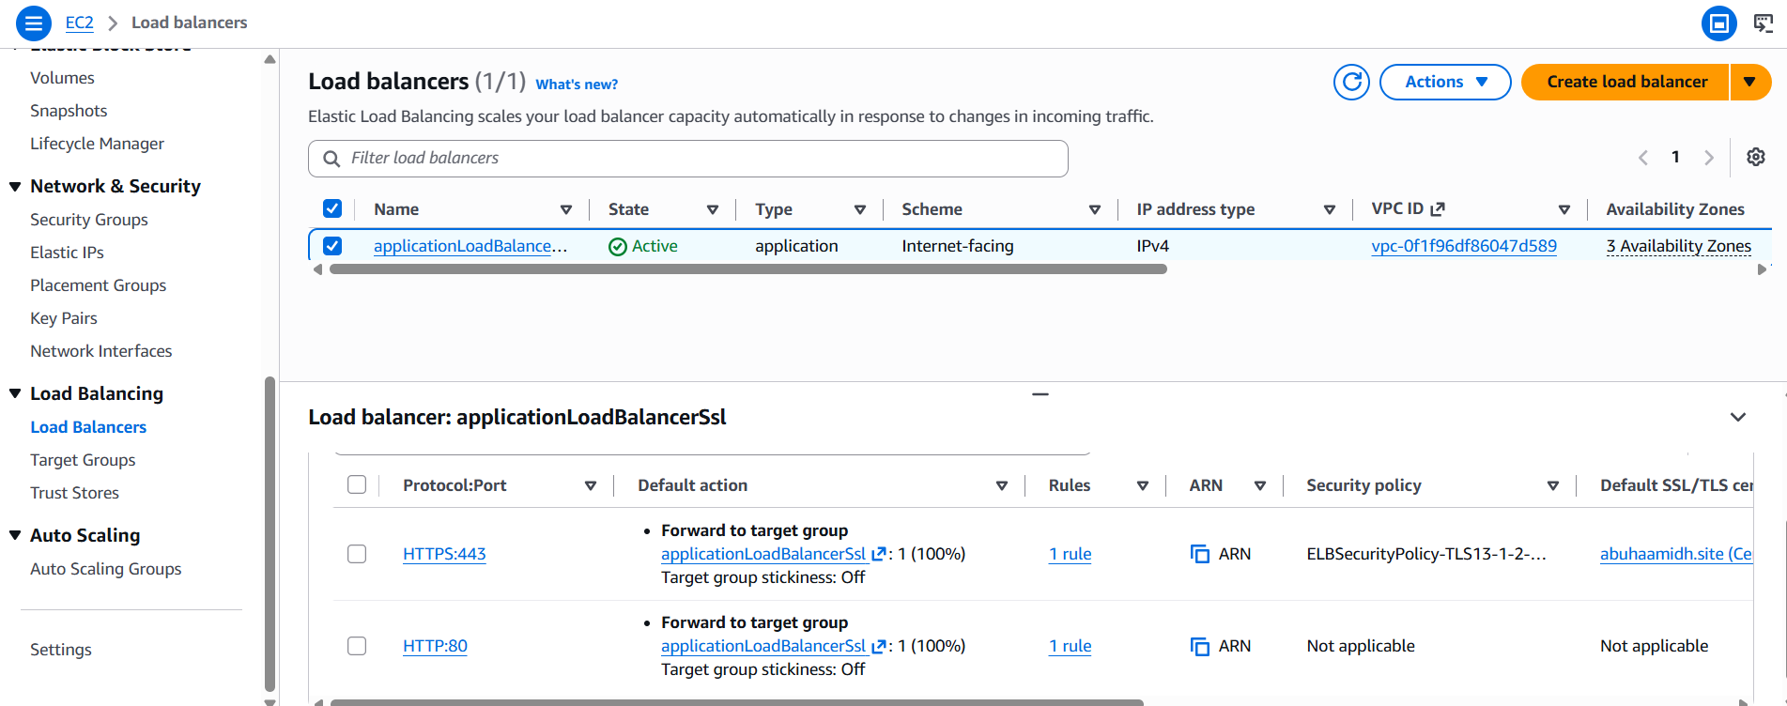
Now if you search it with DNS name, it works in HTTPS protocol
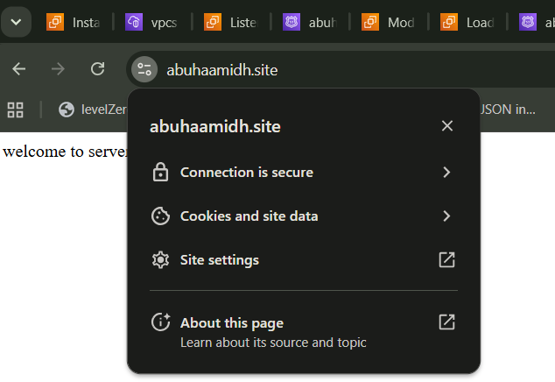

4. Map Application load balancer to R53
Create record and attach the load balancer in the record and configure the alias
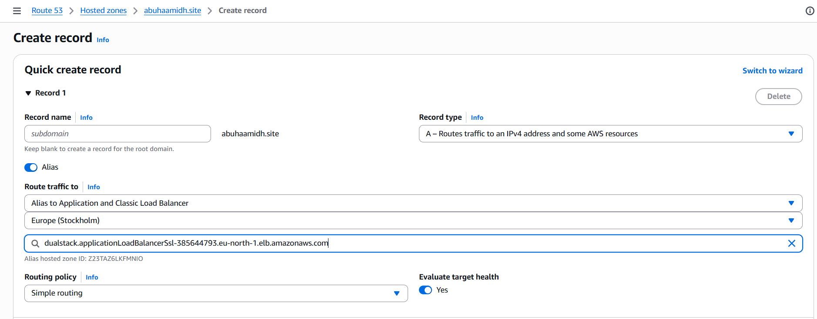
5. Push the application load balancer logs to S3
Enable the access logs for and attach the bucket to it
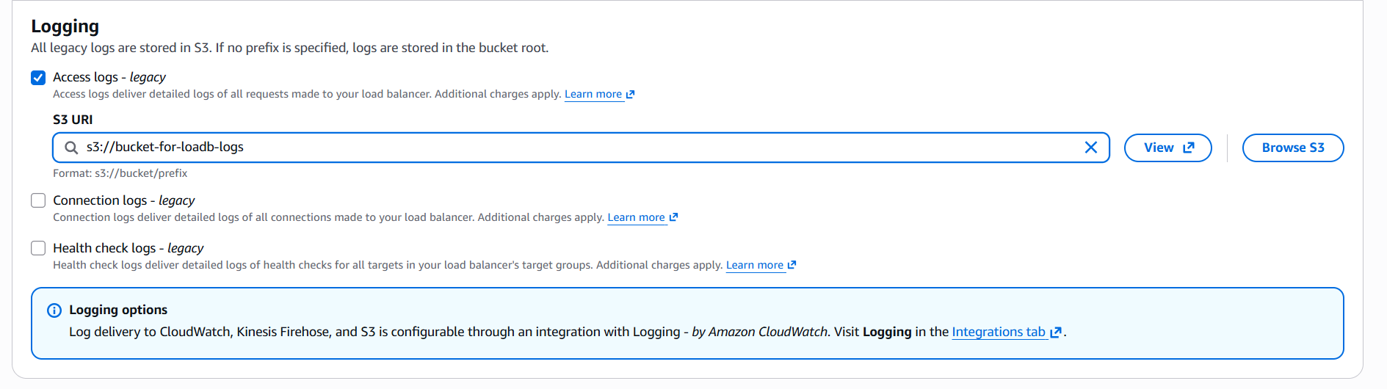
And if you check it in the logs, you can see the logs are being created and visible

